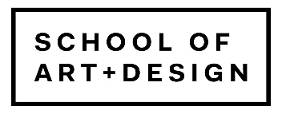

Proposals for an amendment to the Policies and Procedures of the School of Art + Design at the University of Illinois at Urbana-Champaign.

The individuals below propose to amend the Policies and Procedures of the School of Art + Design as indicated in the attached document.

1.
Signature Printed Date

2.
Signature Printed Date

3.
Signature Printed Date

4.
Signature Printed Date

5.
Signature Printed Date

