Business Meal Guidance
Guidance for the individual who will be responsible for paying for the business meal on their T-card or with personal funds to get reimbursed.

University Policy Requirements
- The allowable maximum expenditure for business meals, receptions, and refreshments is $75 per person per meal including alcohol but excluding tip
- This limit applies to all providers, including restaurants, caterers, and UIUC-operated food service providers.
- Do not tip more than 20%.
- University is tax exempt. Show exempt form (attached) and request tax removed from bill (restaurant may not, but required to ask)
- Detailed/Itemized receipt required (alcohol should NOT be separated)
- The business purpose of the meeting/activity (how it benefited the System) as required by the Internal Revenue Service.
- Itemized receipt or invoice detailing all food and beverage purchases.
- The number of attendees.
- Affiliation of attendees. Do not list by name but indicate whether they were employees or non-employees.
- Whether alcohol was served.
- If employees only, please provide an agenda and reason meeting needed to happen during a mealtime.

FAA Policy - due to issues with the per person meal limit, FAA will not support the use of Nando Milano for university related business meals.

Supporting Documentation Include the following information when following your unit’s protocol on reimbursement or T-card expense reconciliation:
- The business purpose of the meeting/activity (how it benefited the System) as required by the Internal Revenue Service.
- Itemized receipt or invoice detailing all food and beverage purchases.
- The number of attendees.
- Affiliation of attendees. Do not list by name but indicate whether they were employees or non-employees.
- Whether alcohol was served.
- If employees only, please provide an agenda and reason meeting needed to happen during a meal time.

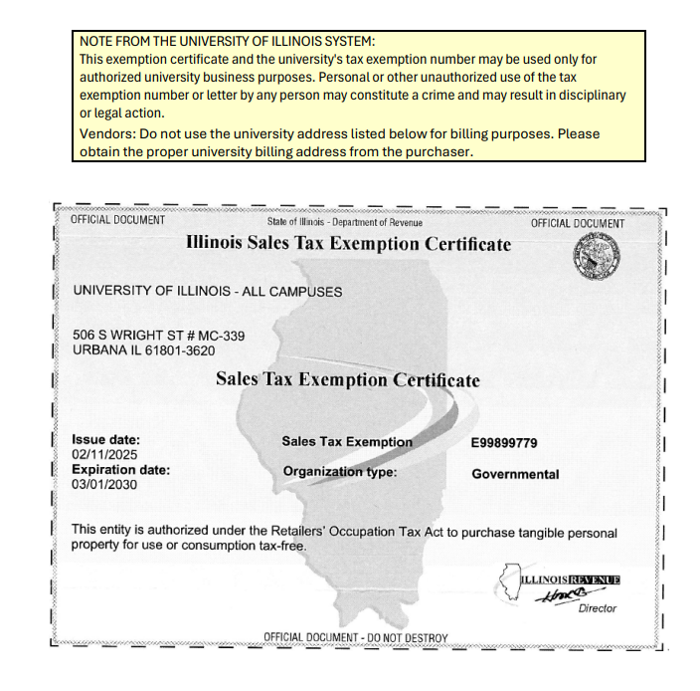

HOW TO SUBMIT A BUSINESS MEAL REIMBURSEMENT REQUEST IN CHROME RIVER
Chrome River Resource Page: https://www.busfin.uillinois.edu/bfpp/section-8-payments-reimbursements/request-reimbursement-travel-business-meals

- Login to Chrome River: https://app.ca1.chromeriver.com/login/sso/saml?CompanyID=illinois.edu

- From the home screen on Chrome River, click the +Create in the Expense ribbon, to create a new expense report.
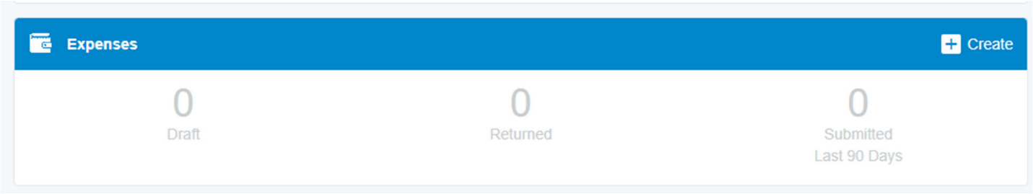
- Complete the Header screen, then click Save.
  - Report Name – use the following, updating the GREEN appropriately.
Draft: DATE & Reason
  - Business Purpose – Describe how the purchase benefits the University (Who, What, Where, When and Why). Use the following, updating the GREEN appropriately.
Draft: The UNIT NAME as part of EVENT held a business meal with NAMES on DATE. This event benefited the University…….
  - Report Type – TCard and Employee Reimbursements
  - Does the beneficiary of the expense work 100% in an approved location that is not owned or maintained by the U of I? Answer accordingly
  - Transaction/Purchase Type – General
  - Trip Type – Non‐Travel
  - Budget Fiscal Year – FY25 (July 1, 2024 – June 30, 2025)
  - User Defined Do not enter anything here
  - Click Save
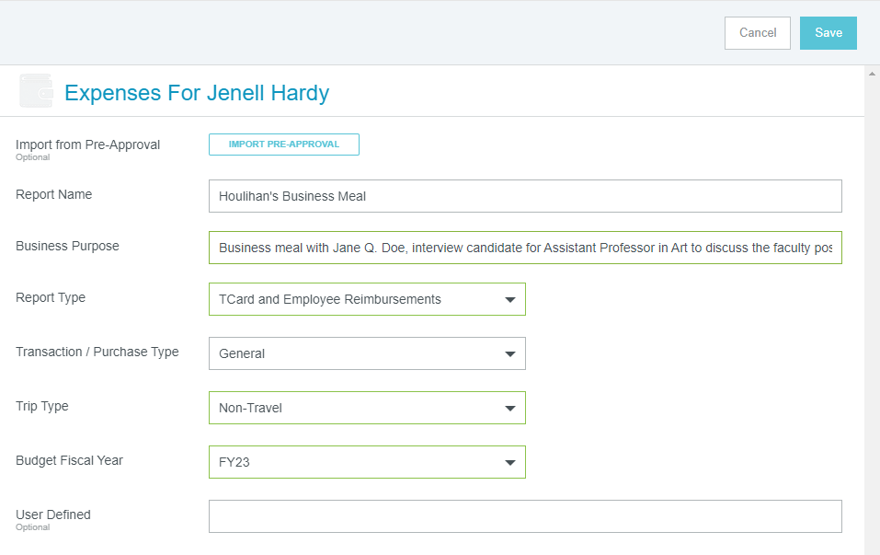

- Under Add Expenses on the right side of the screen, click the +Create New icon, to pull up the mosaic tiles. Select the category that best describes the expense for which you are seeking reimbursement.
Select the MEALS/PER DIEM tile to access the sub expense tiles. Then choose the BUSINESS MEALS sub tile.
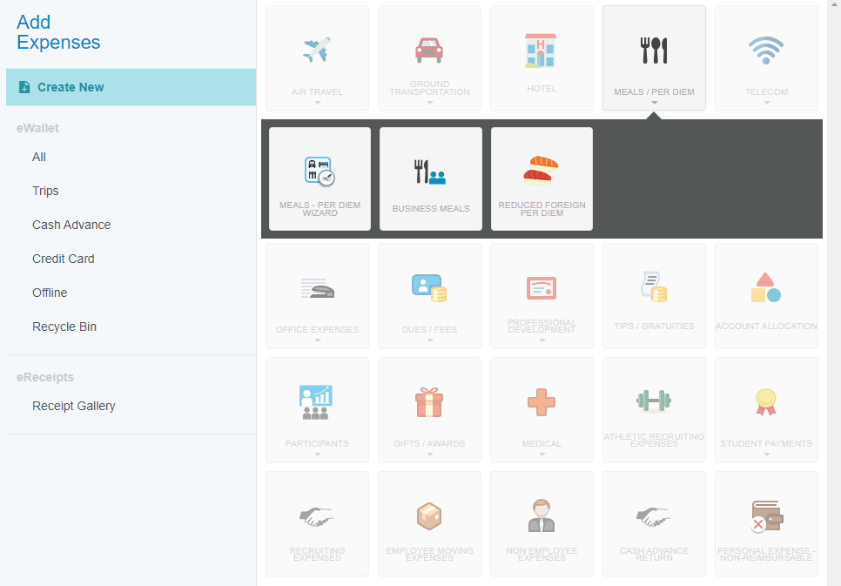

- Complete the Sub Header screen, then click Save.
- Date – Enter the date of the business meal.
- Number of Attendees – Enter the number of people who attended the meal
- Spent – Enter the total amount of purchase.
- Business Purpose – auto populates previous entry from Header screen.
- Description – provide additional information about purchase (optional).
- Allocation – Ask Unit Administration or TBH BSC for CFOP
  - Activity/Location – leave blank unless you have been given this information.
- Attachments – attach your receipt. The receipt total should match the total entered in the Spent field above. The receipt should also be itemized.
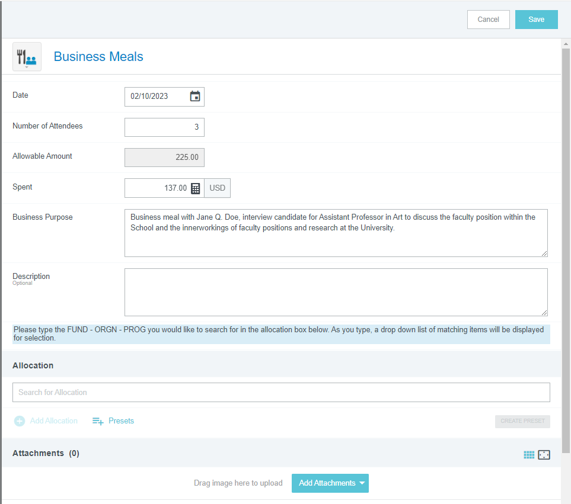

- Add additional expenses and attach receipts (individually), by clicking (+) icon on the Expenses Ribbon. The repeat steps 3 and 4, until all expenses and receipts have been added.

- When all expenses have been added click the green Submit button.

- Click the secondary Submit button that appear.

